DATA ANALYTICS

ASSIGNMENT 8

COLLABORATIVE FILTERING AND CONTENT BASED CLASSIFICATION

TEAM MEMBERS

NAME SRN  
VIMARSHA R PES1201701590

VINUTHA M N PES1201701373

KEERTHI PRIYA P PES1201701643

***COLLABORATIVE FILTERING:***

**collaborative filtering** is a method of making automatic predictions (**filtering**) about the interests of a user by collecting preferences or taste information from other users who are similar to the user.

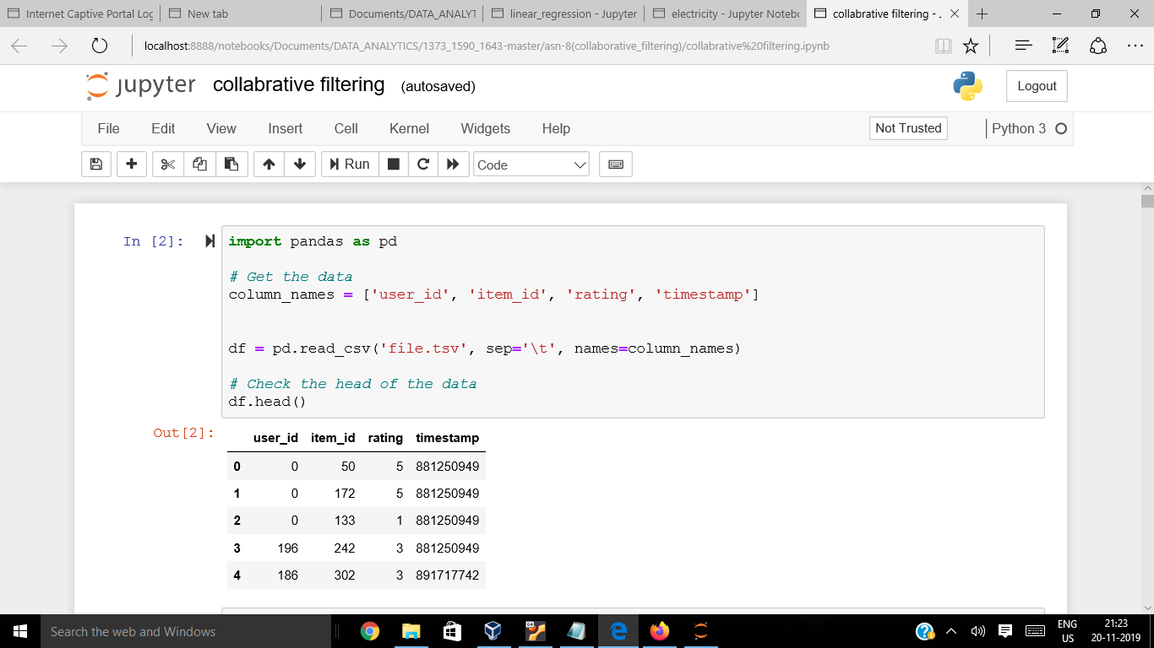

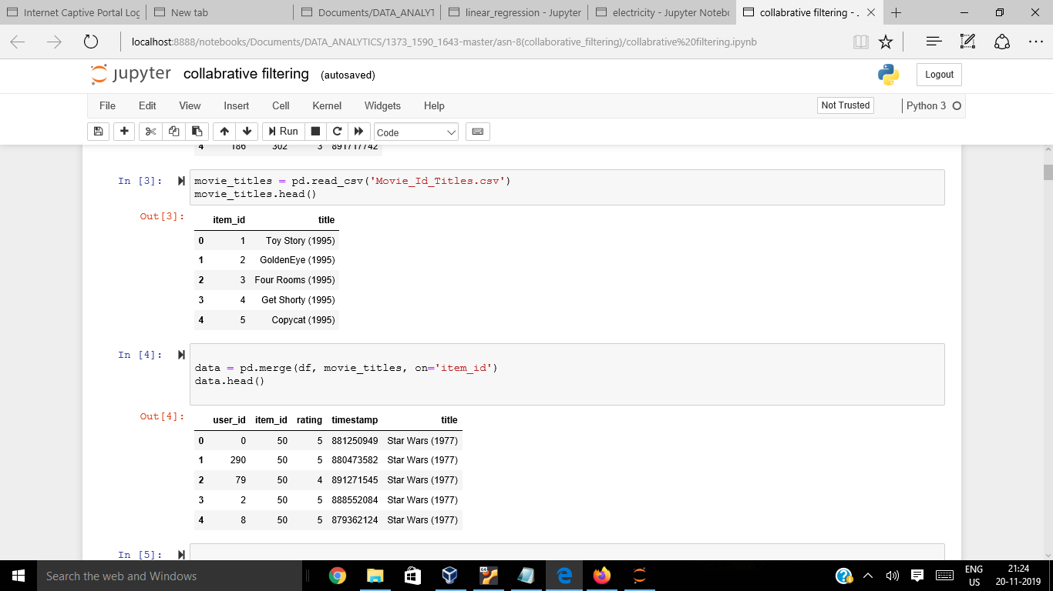

We have taken ***Movie dataset***, calculating ***mean*** rating of all the Movies

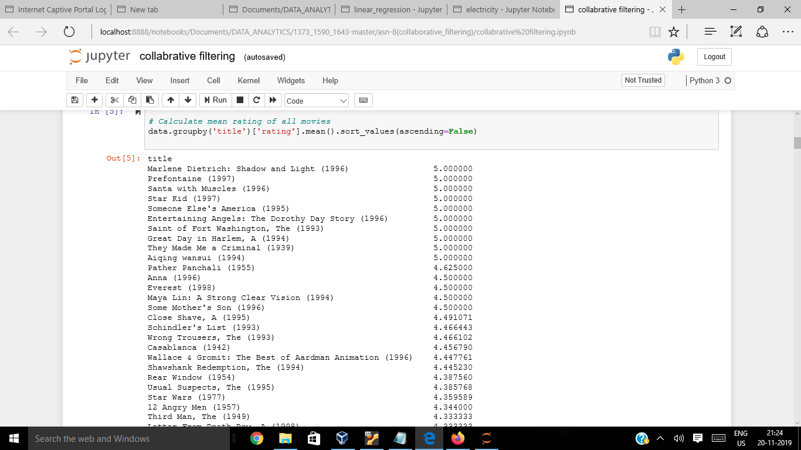

Then Creating Dataframe with ***“Rating***” Count Values

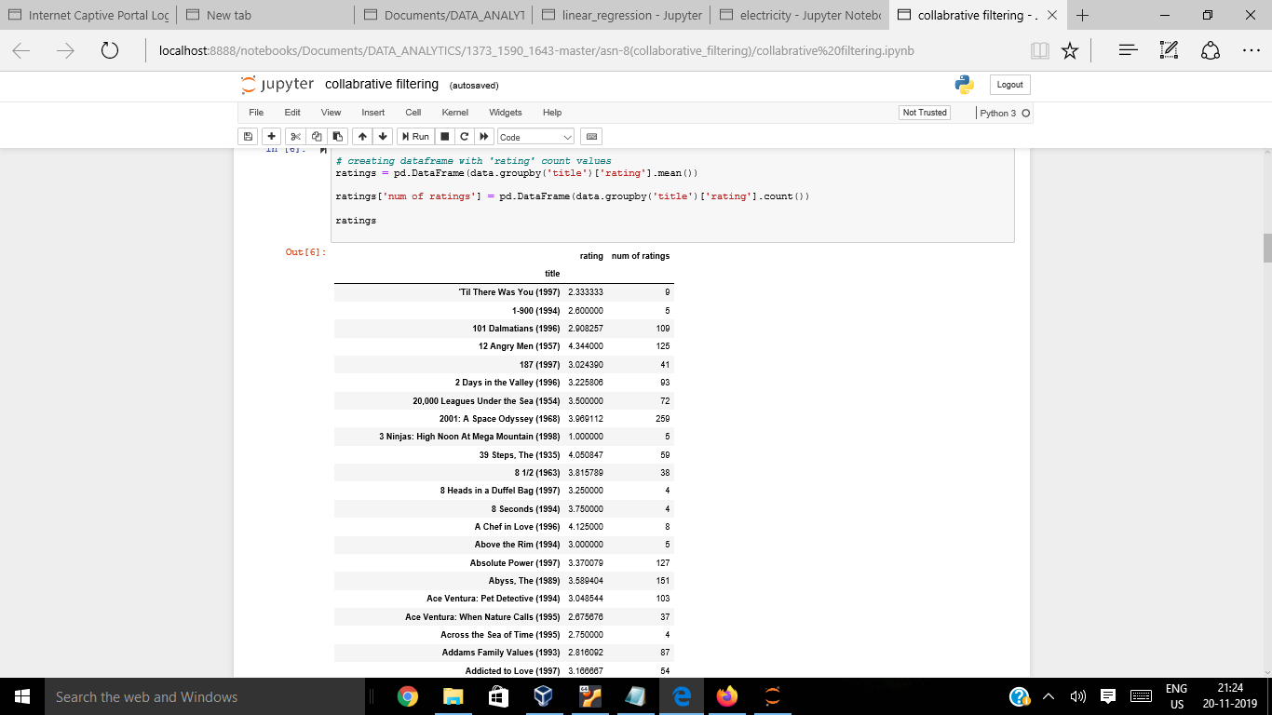

Plotting a graph of ***“number of rating Columns”***

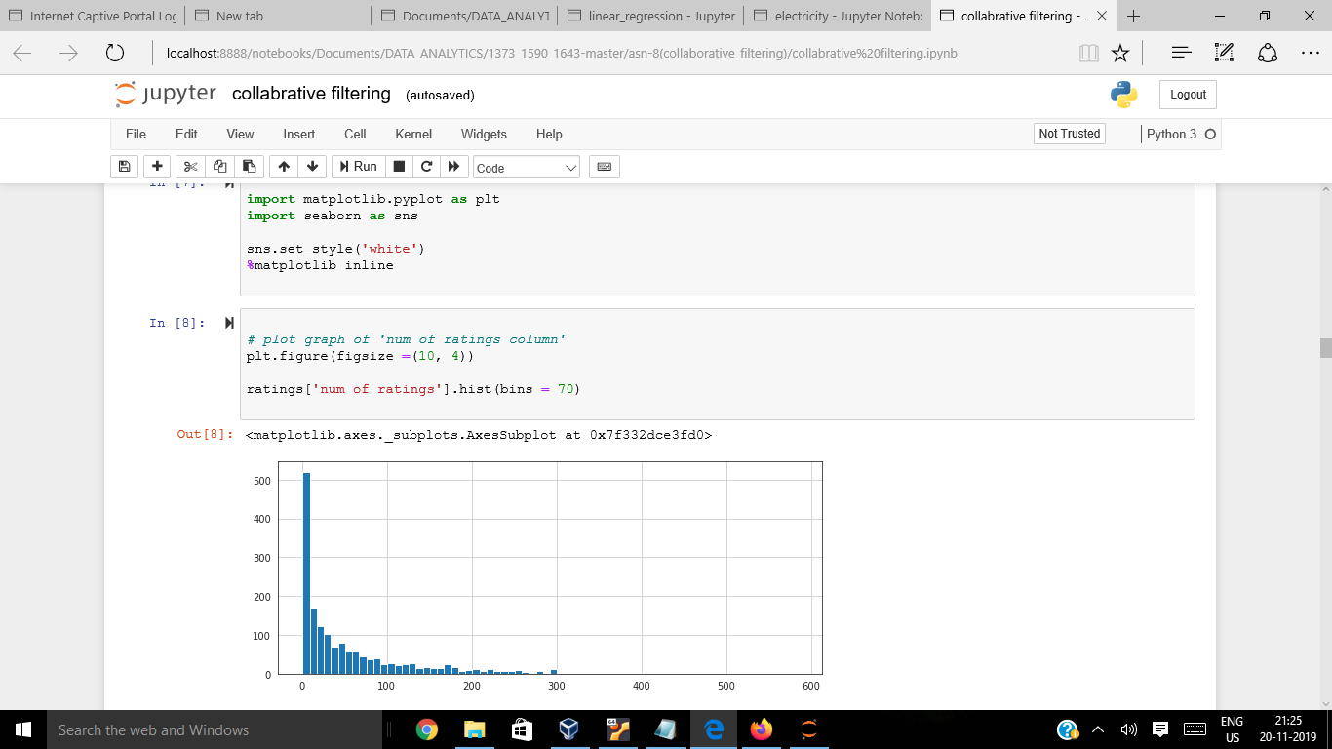

Plotting graph of ***“rating*** “ column

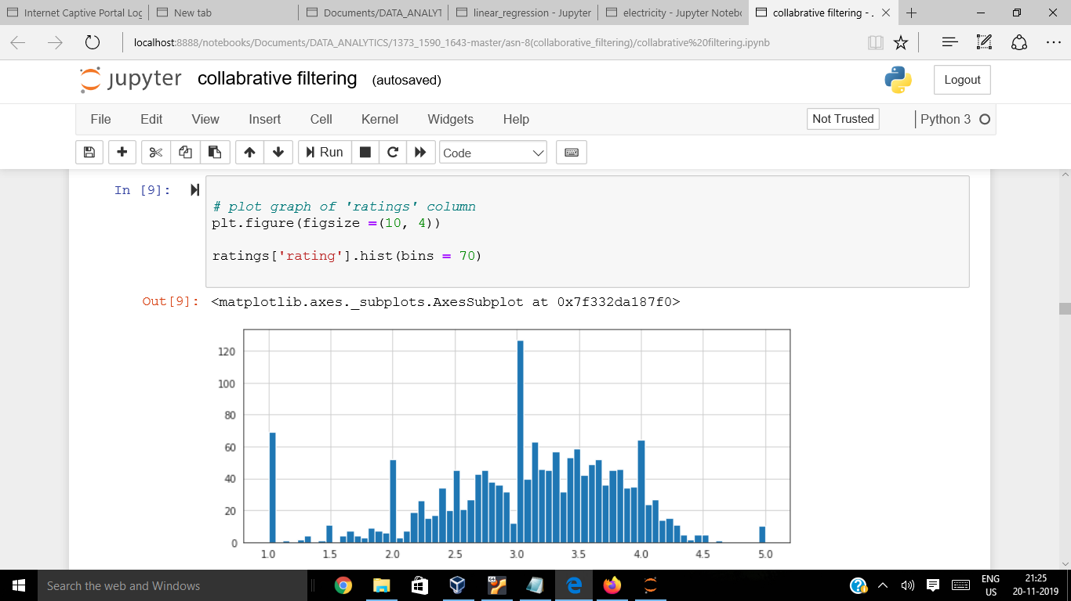

Sorting values according to the “***num of rating column***”

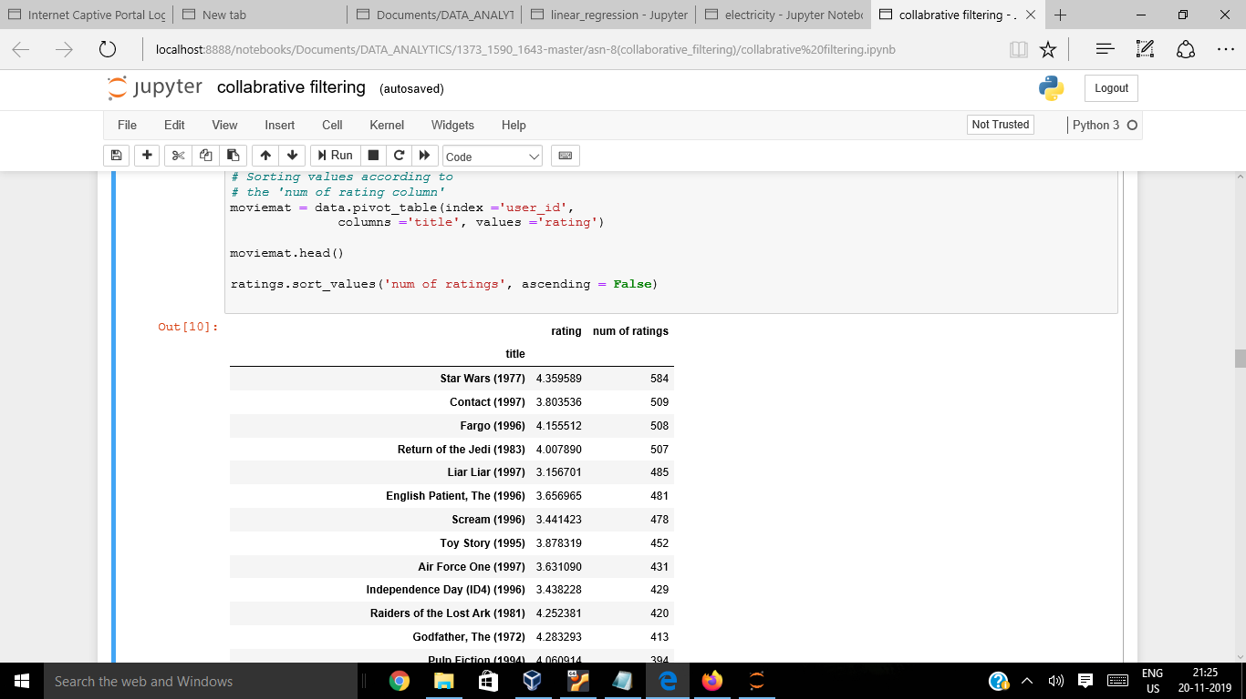

Analyzing ***correlation with similar Movies***

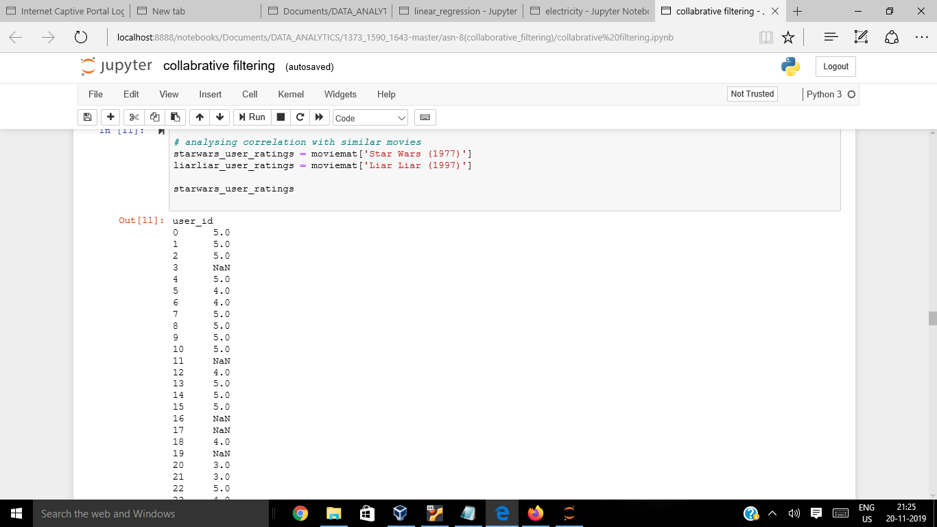

Similar movies like ***“STARWARS”***

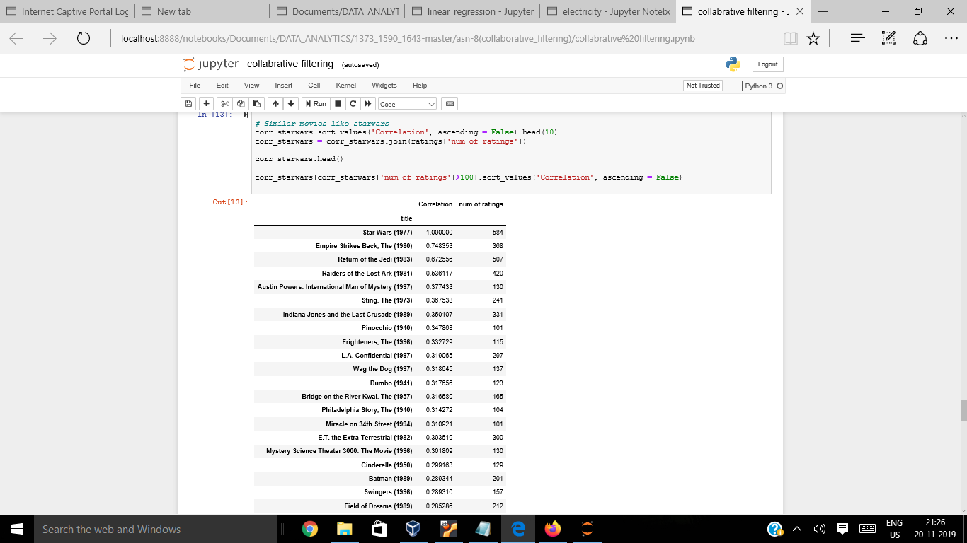

Similar Movies as of ***LiarLiar***

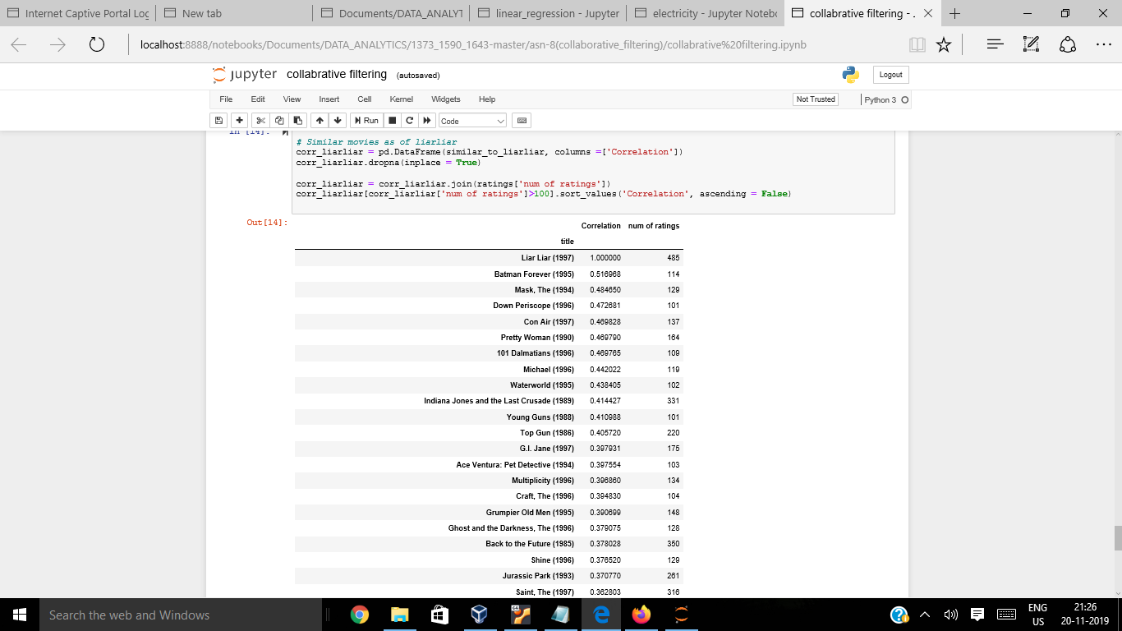

*Likewise we recommend the user by analyzing the movies watched by similar other users*

***CONTENT BASED CLASSIFICATION***

*Content*-*based classification* inspects and interprets files looking for sensitive information. Methods include fingerprinting and regular expression.

